Nehemiah 3 • The Gates of Jerusalem
- (v.1-5) The ____________ Gate & the ____________ Gate
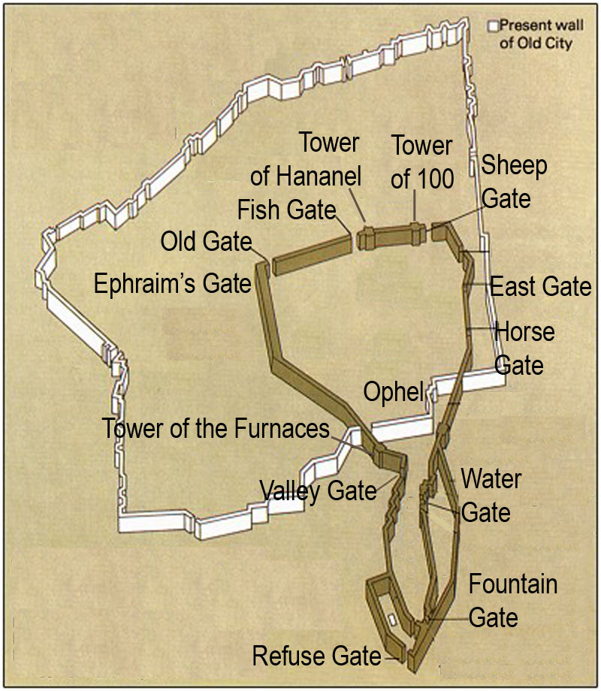

- (v.6-12) The ____________ Gate & the ____________ Gate

- (v.13-14) The ____________ Gate & the ____________ Gate

- (v.15-16) The ________________ Gate

- (v.26-27) The ________________ Gate

- (v.28-29a) The ________________ Gate

- (v.29b-30) The ________________ Gate

