Nehemiah 3 • The Gates of Jerusalem
- (v.1-5) The Sheep Gate & the Fish Gate
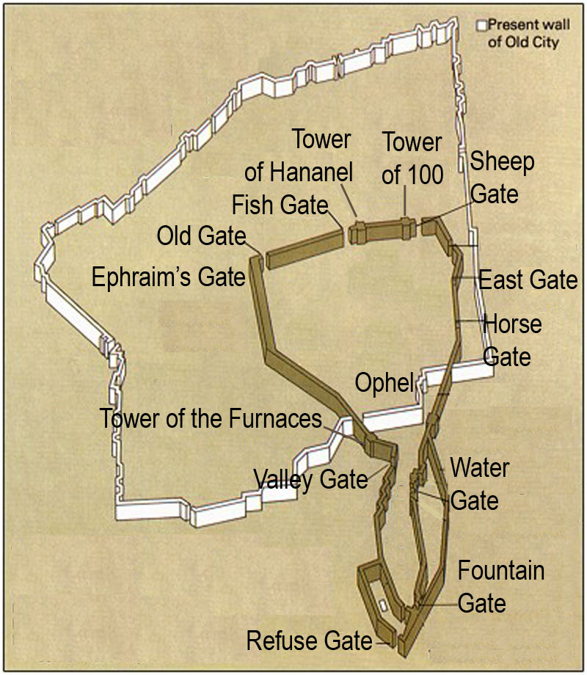

- (v.6-12) The Old Gate & the Ephraim Gate

- (v.13-14) The Valley Gate & the Refuse Gate

- (v.15-16) The Fountain Gate

- (v.26-27) The Water Gate

- (v.28-29a) The Horse Gate

- (v.29b-30) The East Gate

