Nehemiah 3 • The Gates of Jerusalem
Introduction
Nehemiah comes and he sees the devastation, a terrible devastation. And he goes to the king after weeping over the city, and asks the king for a mandate to rebuild what’s been left in ruins. But there’s a spiritual meaning to what’s been left in ruins when he rebuilds the gates.

Now ultimately these gates are what you would see in the book of Revelation, the twelve gates. At different times in history there were different numbers of gates, but they’ve all basically been the same. To some extent they broadly resemble – or vaguely resemble – the pattern of the gates you have in the Old City of Jerusalem today, except that the city then was much, much smaller.

As we look at the gates of Jerusalem in the Old City of Jerusalem today, God is showing us a lesson in history. As you walk through the Old City of Jerusalem, you’re looking at not one thousand, not two thousand, not three thousand, but more than three thousand years of history from the time of the Jebusites onward. And those walls and gates tell a story, a story of revival and backsliding, renewal and decline. And the same is true for the church. Even the walls of Jerusalem and its gates are a reflection of the history of the Jewish people, but also of what’s happened through the centuries with the church.
¹Then Eliashib the high priest arose with his brothers the priests and built the Sheep Gate; they consecrated it and hung its doors. They consecrated the wall to the Tower of the Hundred and the Tower of Hananel.  ²Next to him the men of Jericho built, and next to them Zaccur the son of Imri built.  ³Now the sons of Hassenaah built the Fish Gate; they laid its beams and hung its doors with its bolts and bars.  ⁴Next to them Meremoth the son of Uriah the son of Hakkoz made repairs.  And next to him Meshullam the son of Berechiah the son of Meshezabel made repairs.  And next to him Zadok the son of Baana also made repairs.  ⁵Moreover, next to him the Tekoites made repairs, but their nobles did not support the work of their masters. | The Sheep Gate & the Fish Gate (v.1-5)  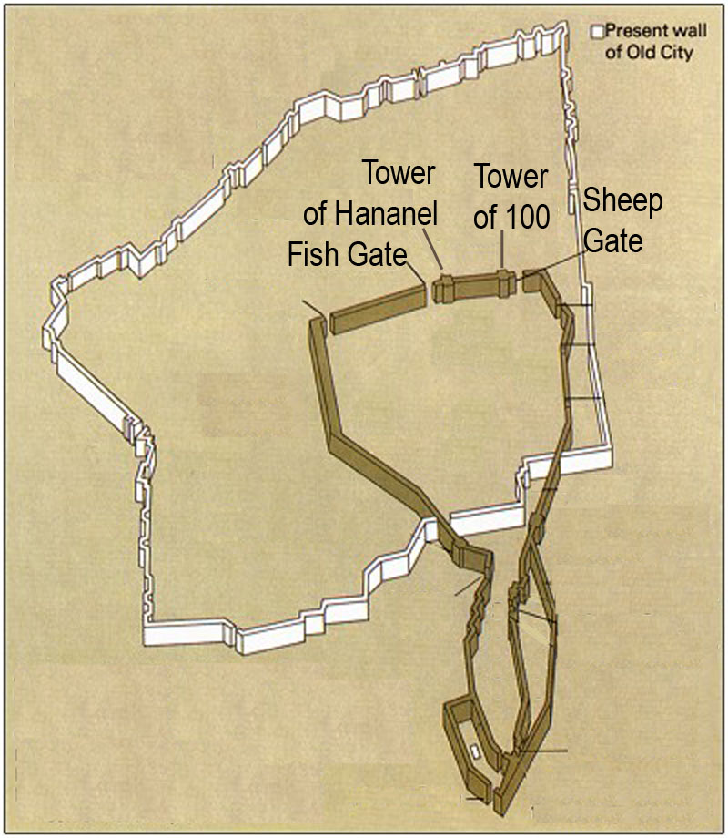The first gate is the Sheep Gate and, next to it, the Tower of Hananel (which means “God’s mercy”) and the Tower of the Me’ah (which means “one hundred”). That is the gate to which they brought the sheep into Jerusalem to be sacrificed in the temple. However, Hananel means “God’s mercy”, or something to do with the mercy of God, and “Me’ah” is the Hebrew word for “one hundred”. Remember when Jesus said if a shepherd loses a sheep, he’ll leave the ninety-nine and go after the one? (Luke 15:3-7) It’s like a dozen eggs: if one egg is missing, you don’t have a dozen. Or if one sheep is missing, you don’t have a proper flock. A proper flock had to be one hundred.  Sometimes, some of us go astray. Sometimes, some of us fall away. Sometimes, young believers backslide. Sometimes, in times of crisis, we feel wrongly that the Lord has abandoned us, and we wander off. But the Good Shepherd comes after us. He doesn’t want to lose any. The Sheep Gate is representative of Christ’s statement, “My sheep will hear My voice.” (John 10:27)  But next to the Sheep Gate is the Fish Gate. “I will make you fishers of men”. (Matthew 4:19) When you and I are born again, we get “caught”. Now, remember when the apostles fished and they kept one hundred fifty-three, but threw the other ones back? There’s good fish and bad fish. Some people will go back to the world.  But then it continues, and it talks about the different people according to their families and tribes, rebuilding the gates.  “The nobles did not support the work of their masters”. (v.5) When people set out to rebuild what’s devastated, when people set out to repair the gates of God, when people set out to restore what used to be, one problem you’ll have is you may not be able to trust the nobles. So often you’ll find – now there are exceptions – but the people who you’d think would be the most ready and certainly the most capable of contributing the most, the people who’ve been saved the longest, the people who would seem to know the Bible the best, sometimes the people who are the most educated or are the most affluent in a fellowship will be the ones who are most reluctant to get on with beginning again.  Most of the times God has brought about a rebuilding of the broken, it has usually – in fact, almost always – through poor people, through the working classes. In the big revivals in South America: it’s the barrios, it’s the slums. John Wesley’s revivals in England: it was the coal miners; they were like the lowest of the working class. That’s where the Gospel prospered. The middle class people God will use in rebuilding a devastated church will be those who become servants of the poor and of the working classes. Don’t trust the nobles. Don’t think the people who you’d expect to help you rebuild the gates are going to take to the work too quickly. People like that tend to like their comfort too much, they tend to like their position, they don’t like the boat rocked too much, they’d rather make due with what they have. This is because if they try to rebuild something, it’s going to cost them something. The nobles don’t support the work of the masters. Generally it’s the salt of the earth people who are going to get things done.  Application: Discuss what the Sheep and Fish Gates mean to you personally. What seems to be the most important first steps towards rebuilding what was broken? What lessons are to be learned from who is and who is NOT willing to participate?
⁶Joiada the son of Paseah and Meshullam the son of Besodeiah repaired the Old Gate; they laid its beams and hung its doors with its bolts and its bars.  ⁷Next to them Melatiah the Gibeonite and Jadon the Meronothite,  the men of Gibeon and of Mizpah, also made repairs for the official seat of the governor of the province beyond the River.  ⁸Next to him Uzziel the son of Harhaiah of the goldsmiths made repairs.  And next to him Hananiah, one of the perfumers, made repairs, and they restored Jerusalem as far as the Broad Wall.  ⁹Next to them Rephaiah the son of Hur, the official of half the district of Jerusalem, made repairs.  ¹⁰Next to them Jedaiah the son of Harumaph made repairs opposite his house.  And next to him Hattush the son of Hashabneiah made repairs.  ¹¹Malchijah the son of Harim and Hasshub the son of Pahath-moab repaired another section and the Tower of Furnaces.  ¹²Next to him Shallum the son of Hallohesh, the official of half the district of Jerusalem, made repairs, he and his daughters. | The Old Gate & the Ephraim Gate (v.6-12)  So the next gate is the Old Gate. But we also know that next to the Old Gate there was another gate called the Gate of Ephraim. “Ephraim” means “fruitfulness” or “doubly fruitful”. And it was at the beginning of a long valley, a depression called “the valley of the cheese makers” or the Tyropean Valley. Now this valley runs through the present center of the Old City of Jerusalem and you can see parts of where it was, the wall running parallel to it, excavated.  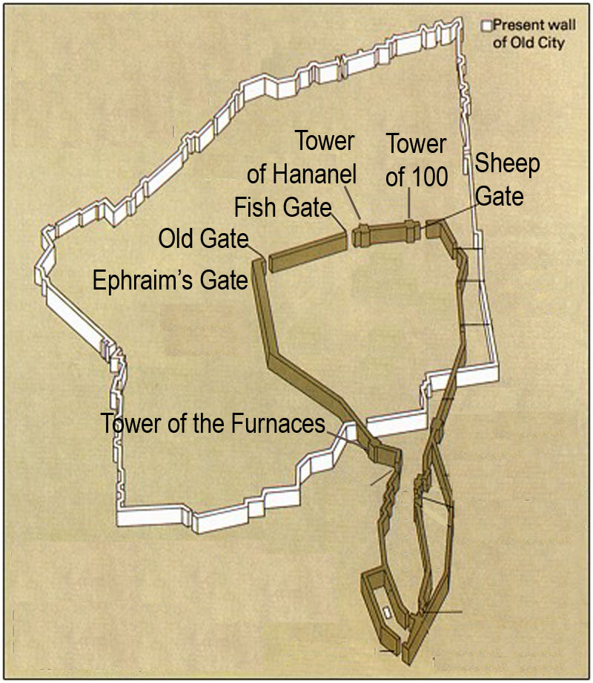  A Christian will progress; there’ll be a choice: two more gates, the Old Gate and the gate of Ephraim. We might be called like a sheep, we might be caught like a fish. When somebody’s first saved, the first few days are absolutely amazing. The scales have fallen off their eyes. Now they see the truth. But after two or three days they begin to come to their senses, or so they think. Is this real? Is this what I really want to commit myself to? Is this really the way I want to live my life? Is it going to be like this, that I’m not going to be able to go out and gamble and get drunk and take drugs and sleep with women and fool around with other men and cheat on my wife and to stop smoking? Is this really for real? Then the social pressures begin. Your old friends, your old desires confront you, and within a couple of days you’re faced with a choice.  Think of Matthew 13, the sower and the seed. Three out of four seeds don’t end up so well. You see this in a lot of places. You see it, certainly, in Israel among the Jews. The social cost is much higher than it is for non-Jews most of the time. Among Muslims its even higher. People like that will count the cost more carefully before they get saved. In Ireland it’s Catholic people. If you’re seen as becoming a Protestant, you’re betraying your family and all this kind of stuff – the cost is higher. When people get saved in prisons, prison can be quite dangerous. You become a Christian, people will try to kill you, try to push you sometimes to the limit to see how far they can make you go before you react violently the way you used to. It’s not easy. There’s a much higher cost involved with those kinds of people. People who get saved under those conditions will tend to be less likely to backslide because they’ve counted the cost more carefully to begin with.  Other people – most of us – find ourselves in this situation: So you’ve come through the Sheep Gate, you’ve come through the Fish Gate, but now there’s two gates in front of you. Which one are you going to go through, the gate of fruitfulness or the Old Gate, the gate of “back to your old ways, your old friends, your old interests” – which gate are you going to walk through? And again, this Old Gate lies at the precipice of a decline, of a valley. A long valley. A deep valley. The Tyropean Valley.  Valleys in the Bible represent times of trial. What does it say in Matthew 13? But when opposition comes because of the Word they fall away. (Matthew 13:20-21) In the beginning they seem to grow really quick, but they have no depth. After somebody gets saved, they go through their first trials, sometimes prolonged periods of trial. We go through a valley.  But as for those doing the work, take particular note that there was something for everybody. There were things for men to do, things for women to do, things for people from all backgrounds, trades, professions, and walks of life. Everybody is involved. (“Uzziel” means “my strength is God”; “Malchijah” means “my king is Yahweh”.)  Application: Discuss what the Old and Ephraim Gates mean to you. How do they relate to the choices you have faced or currently face? What is the lesson to be learned in the fact that there was something to do for everyone?
¹³Hanun and the inhabitants of Zanoah repaired the Valley Gate. They built it and hung its doors with its bolts and its bars, and a thousand cubits of the wall to the Refuse Gate.  ¹⁴Malchijah the son of Rechab, the official of the district of Beth-haccherem repaired the Refuse Gate. He built it and hung its doors with its bolts and its bars. | The Valley Gate & the Refuse Gate (v.13-14)  The next gate you come to is the Valley Gate, but that leads us to another gate called the Refuse Gate. Outside of the Refuse Gate was the garbage pit of Jerusalem, where the Tyropean Valley met another valley called the Valley of Hinnom. In this Valley of Hinnom is where backslidden Judah sacrificed their children to Molech. (2 Kings 23:10) But outside this gate where these two valleys came together – actually there was a third valley on this side called the Kidron, the three of them came together – you’d have the garbage pit which burned day and night. That garbage pit was called “Gehennom” – “Gehenna”, the same word which is translated as “hell” in Scripture. This is the representation of hell outside of the Refuse Gate where these three valleys came together.  We go through the Sheep Gate or we go through the Fish Gate. If we decide to hold onto our crosses and keep following the Lord Jesus, we choose fruitfulness and go through the gate of Ephraim. The old nature comes up and how does God deal with it? We go to the Valley Gate. God uses the valley, He uses difficulty, He uses times of trial to deal with our old nature. But when we come to the end of the valley, we get to the Refuse Gate. Trials are difficult when you’re going through them, but when they’re over, you see how much garbage God has thrown out of our lives. That’s what He wants to do.  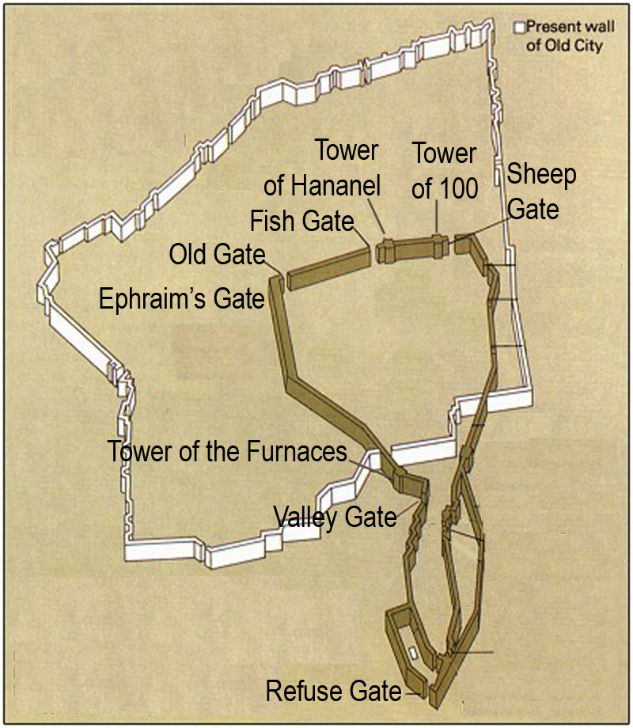Philippians 1:6, “...He who began a good work in you will bring it to completion in the day of Christ Jesus”.  God wants to throw all the garbage out of our lives. And although we don’t like it – and understandably we don’t like it – one of the ways God removes the rubbish from our lives is by bringing us into times of trial. He brings us through the Valley Gate. What does it say in James? Count it as all blessing, my brethren, when you go through these trials. (James 1:2)  Application: Discuss what the Valley and Refuse Gates mean to you. How does this relate to what you’ve gone through in the past or may be going through now? How do you see this relating to the overall process of rebuilding something that is broken?
¹⁵Shallum the son of Col-hozeh, the official of the district of Mizpah, repaired the Fountain Gate. He built it, covered it and hung its doors with its bolts and its bars, and the wall of the Pool of Shelah at the king’s garden as far as the steps that descend from the city of David.  ¹⁶After him Nehemiah the son of Azbuk, official of half the district of  Beth-zur, made repairs as far as a point opposite the tombs of David,  and as far as the artificial pool and the house of the mighty men. | The Fountain Gate (v.15-16)  Now this Pool of Siloach is where, through Hezekiah’s tunnel, the water was brought into the Old City. It’s also the place where Jesus would later open the eyes of the blind man.  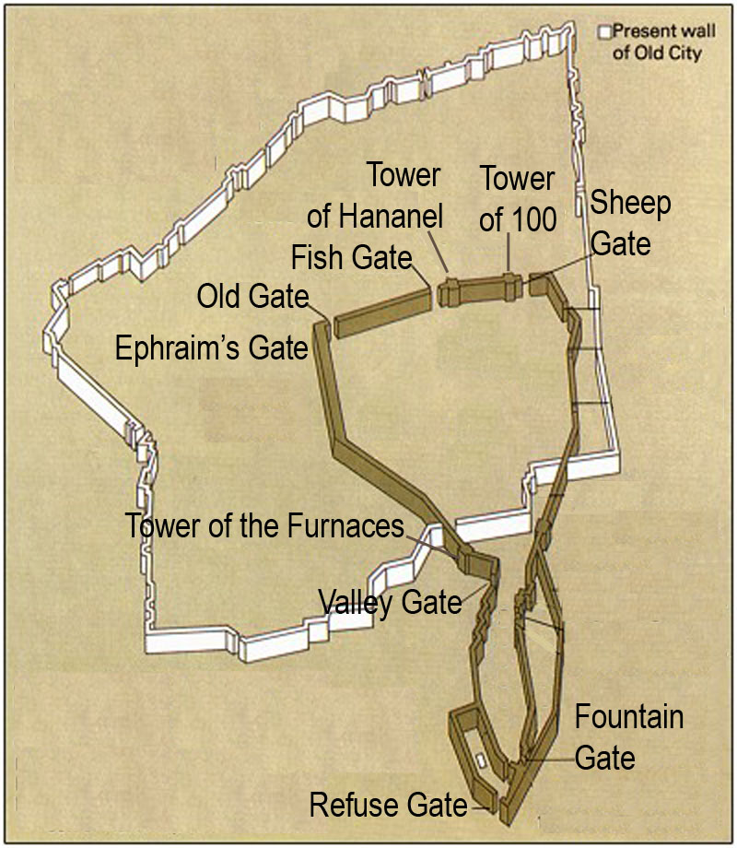As you proceed, not far away you come to the next gate – the Fountain Gate – where the Pool of Siloach was located, where the water began to flow.  Scripture teaches us (John 7:39; Isaiah 44:3) that this freshly clean water which came from the Pool of Siloach, entering the city through Hezekiah’s tunnel, this water was called “chay mayim” – “living water”. Which in Isaiah and John is always a type or figure of the Holy Spirit.  Let’s understand this in light of the present situation. In our sense of desperation over what is happening to our nation and the other protestant democracies and the state of the church, with Islam and New Age taking over – we see the church failing. Christ is not failing, but the church is not winning. Ultimately the church is victorious because of Christ and His return, but right now we’re losing. We’re losing the battle to homosexuals, to New Age, to ecumenism, to everything. However, for the people wanting to see something happening, they want to see the Living Water flow. They want to see the fountain, they want to find it, but they’re not willing to do what’s necessary to make it flow. They don’t want to go back to the basics. The only way you’re going to get to the Fountain Gate is by going back to the basics.  Do you know, so many of the biggest churches of this country don’t even preach the Gospel? They don’t even talk about the blood of Jesus, or the cross, or repentance – that’s not what they talk about. They talk about power and victory and all that stuff -- the “Kingdom Now” stuff – without realizing that the only way you’re going to get the power or the victory is because of what Jesus did on the cross and when He rose from the dead. They’ve got everything wrong.  So they don’t want to go back and look at the choice we have to make. The choice we make is do you want the Old Gate or do you want the fruitful gate? The Old Gate is the gate of our life in this world. If you can really define “backsliding” in its simplest terms, you’d say it means “hoping in this world”. Backsliding is hoping in this world. When somebody’s backslidden, it means they’re trusting in this world.  There are many who don’t want to realize we have to go through a long valley, that there’s a lot of garbage in our lives. (There’s certainly a lot of garbage in my life.) But even more importantly, there’s a lot of garbage in the church that has to be gotten rid of. We all want the Living Water to flow, but it’s not going to flow until God gets the garbage out that’s clogging up the drains and clogging up the pipes and clogging up the water system. There’s too much rubbish.  Living Water doesn’t flow that way. It flows when you get rid of the refuse, when the Lord has a free hand to do the things He needs to do in our lives and in the church to get rid of the garbage. When they get rid of the hype, and the “Kingdom Now”, and the replacementism, and the ecumenism, and the prosperity/money preachers, then maybe the water will begin to flow because the plumbing system won’t be clogged up any more with dreck.  Application: Discuss what the Fountain Gate means to you. How does it apply to our approach to rebuilding something is broken? Is there a shortcut to experiencing the power of the Holy Spirit?
²⁶The temple servants living in Ophel made repairs as far as the front of the Water Gate toward the east and the projecting tower.  ²⁷After them the Tekoites repaired another section in front of the great projecting tower and as far as the wall of Ophel. | The Water Gate (v.26-27)  But the next gate is what we find at the other terminal of Hezekiah’s tunnel: the Water Gate. There’s an underground tunnel which flows from the Fountain Gate to the Water Gate that was built by Hezekiah. It’s still there.  God doesn’t want us to just have a fountain; He wants us to have a pool. He wants us to be immersed in His Spirit. A Spirit-filled life. A Spirit-filled church. There might be a certain amount of water, but not enough to do what God wants.  People who are Cessasionists – churches which say the gifts of the Spirit ended with the Apostles – people like that have the Holy Spirit in some measure, but they’re unwilling to open to the fullness of the Spirit, including the gifts. Now I never seek the gifts above the Giver, I seek the Giver. But Cessasionism is as wrong on one extreme as the excesses of the other. There’s a balance. Who’s going to burn their money because money can be counterfeited? Nobody. Nobody should throw the baby out with the bath water, should they? Unfortunately, some people do.  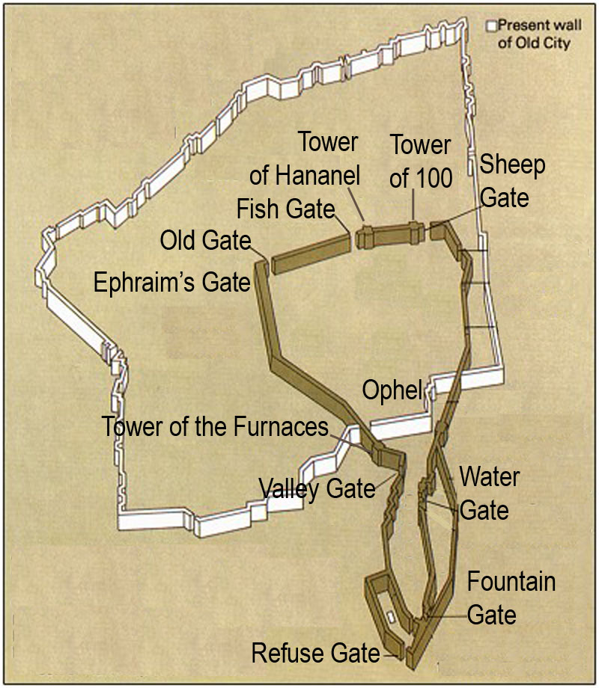But after the Water Gate, the journey continues and they make repairs. It’s a progression. We go from the Refuse Gate down to the Fountain Gate. After the Fountain Gate we come to the Water Gate.  Application: Discuss what the Water Gate means to you. What is the difference between simply having the Holy Spirit and living a Spirit-filled life?
²⁸Above the Horse Gate the priests carried out repairs, each in front of his house.  ²⁹After them Zadok the son of Immer carried out repairs in front of his house. | The Horse Gate (v.28-29a)  We’ve covered the north, west, and south sides of Jerusalem; now we’re going to the east side, which is the closest to what you see today to the archeology of the original Old City. This wall would have been on the same location – or approximately the same location – as the present eastern wall facing the Mount of Olives, separated from it by the Kidron Valley. Not far away then, as you turn east, is the Horse Gate.  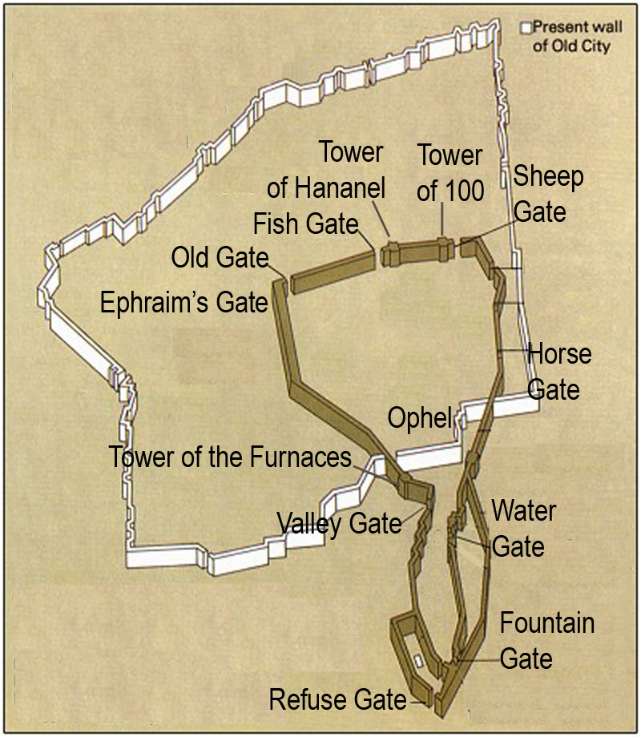Horses in biblical times were not used for transport. In the ancient Near East, donkeys and camels were animals for transport. Sheep were used for meat and wool, cattle were used for meat, hides, and milk. A horse had only one purpose, only one function: the horse was the animal of war. It was used for pulling chariots and for mounted soldiers for cavalry. That’s all.  You see, until we have a Spirit-filled church and a Spirit-filled life, we’re not really ready for war.  The church in this country is no longer in a spiritual state to take on New Age. It’s not in a spiritual state to take on Islam. We couldn’t win. Islam claims to have a moral agenda from Allah to restore with Shariah – Islamic law – a standard of morality that Christianity can no longer deliver. They claim that. You wouldn’t have the present level of crime if you had an Islamic state, you wouldn’t have this thing of single-parent families in an Islamic state, you wouldn’t have homosexuality in an Islamic state. Homosexuals? We kill them. Thieves? We chop off their hands. Rape? We castrate. Feminists? We flog them. Shariah-based Islam can restore what this country no longer has morally. The church in this country can no longer deliver a standard of moral righteousness. At one time it could -- at one time it did – but it can’t any more.  No, until you have a Spirit-filled church, you’re not ready to go to war. You can’t go through the Horse Gate until you go through the Water Gate, but you’re not going to get any water until God gets rid of the refuse. And He’s not going to get rid of the refuse until we realize that He has to get rid of it. We’re not even calling it refuse. The desire to trust in this world is refuse.  When so-called spiritual leaders such as, Andrew Shearman, say this world is his home, they don’t even call it garbage. They don’t even recognize that’s what it is.  Application: Discuss what the Horse Gate means to you. Provide examples where sincere attempts to rebuild or reconcile have probably failed due to seeking to avoid the gates leading to the Horse Gate, or at least changing their order.
And after him Shemaiah the son of Shecaniah, the keeper of the East Gate, carried out repairs.  ³⁰After him Hananiah the son of Shelemiah, and Hanun the sixth son of Zalaph, repaired another section.  After him Meshullam the son of Berechiah carried out repairs in front of his own quarters. | The East Gate (v.29b-30)  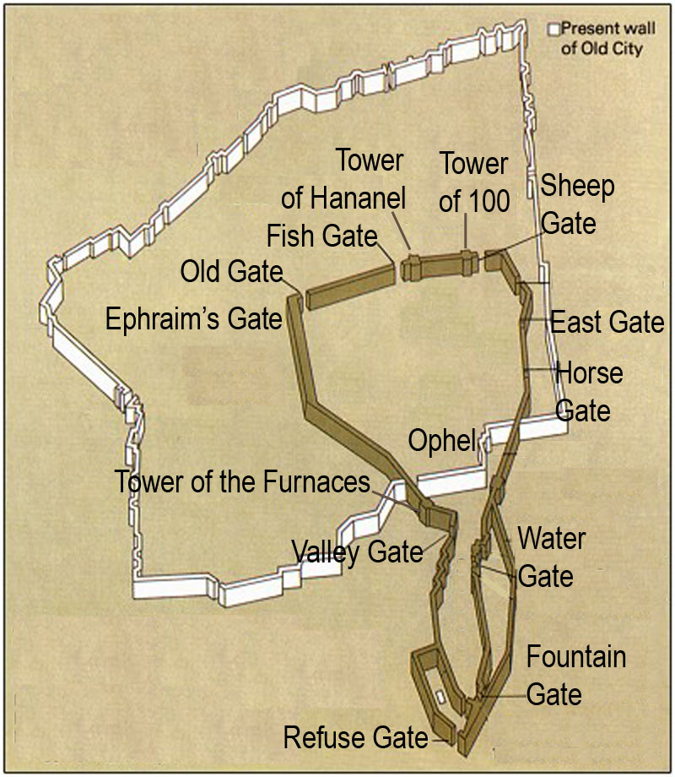The East Gate we call, sometimes, the Golden Gate. The East Gate is the gate through which Jesus came on Palm Sunday.  The evangelical, Christian archeologist Dr. Jim Fleming is one of the people who discovered the Herodian stones under the present East Gate. What that means is we can be quite certain that the present East Gate is where the East Gate which Jesus came through was located. But it also is opposite a certain point on the Mount of Olives where the High Priest had to stand with the red heifer on Yom Kippur and look through the East Gate into the Holy of Holies from across the Kidron. That would tend to verify the theory of Dr. Asher Kaufman of the Department of Antiquities of Hebrew University that would put the location of the original temple not on the exact site of the Mosque of Omar – the Dome of the Rock – but about seventy meters north of it. In other words, in order to rebuild the temple, you would not have to tear down the mosque.  Wouldn’t it be something if the Antichrist just had an ecumenical center up on the temple mount? Jews and Arabs worshiping together up on the temple mount?  You see that Jerusalem is the center of controversy of all the nations. And somehow the Antichrist will have to bring a false peace. One way you could get Jews to negotiate over Jerusalem – even Orthodox Jews – was if you got the Muslims to agree to allow them to rebuild the temple up on the temple mount. OK, let us rebuild our temple, then we’ll allow you to have east Jerusalem. You have yours, we’ll have ours, we’ll all live together.  It’s interesting that the Israeli government asked the papacy, before Rabin was killed, to play a role in Jerusalem being, somehow, a united city of all faiths. Jerusalem is holy to three false religions:  - Nominal Christianity – In Jerusalem, when you go to the Church of the Holy Sepulchre, you’ll see the people kissing stones and praying to icons and idols of all sorts, open idolatry and superstition.  - Rabbinic Judaism – The false Judaism of the rabbis which denies its own Messiah, Yeshua.  - Islam – On the Dome of the Rock, on the outside of the periphery, is a quotation from the Sorat in the Quran, “God has no son”.  We’re told in John’s epistle, that which denies the Father-Son relationship, and denies Jesus is the Messiah is antichrist. Already the Antichrist is setting himself up to be worshiped.  I’m not saying the temple has to be rebuilt, I’m simply saying it looks like it’s going to be. Of course, the Abomination of Desolations I’m worried about is what’s already happening in the church: inter-faith worship and ecumenism. The church is declared to be the temple of God in seven places in the New Testament. There are different Greek words: “oikos”, “naos”, “heiron”. But in seven places we’re told the church is the temple or the tabernacle now. And when you see inter-faith worship with Hindus and Sikhs and Muslims, and with Rome in so-called Christian churches, you’re already seeing the Abomination being set up in the temple. This is rebuilt in the image of the Antichrist. Once it is set up, it will only be a reflection of what’s already become a spiritual reality. And so it is.  The East Gate always has to do with the coming of the Messiah. We have a prophecy in the book of Ezekiel that the East Gate would be shut up after the Messiah entered. We had a sultan of the Turks when the Turks occupied Israel, who knew the tradition of the Jews which said the Messiah would have to come through the East Gate. And so he ordered it sealed up so the Messiah would not be able to come through it. He sealed up the East Gate. We read about this in Ezekiel 44:1...  Then He brought me back by the way of the outer gate of the sanctuary, which faces the east; and it was shut. The Lord said to me, “This gate shall be shut; it shall not be opened, and no one shall enter by it, for the Lord God of Israel has entered by it; therefore it shall be shut.  Now Jesus entered the East Gate on Palm Sunday. And this gate, right now as you see, is sealed up. So after the Messiah went through this gate, it would be sealed up. And it is. It was literally fulfilled. You can look at the gate. But it also says that God would enter through it. Jesus was God; He entered through the gate and this prophecy of Ezekiel 44:1-2 is literally fulfilled: The coming of Jesus.
³¹After him Malchijah, one of the goldsmiths, carried out repairs as far as the house of the temple servants and of the merchants, in front of the Inspection Gate and as far as the upper room of the corner.  ³²Between the upper room of the corner and the Sheep Gate the goldsmiths and the merchants carried out repairs. | The Gate of Judgment (v.31-32)  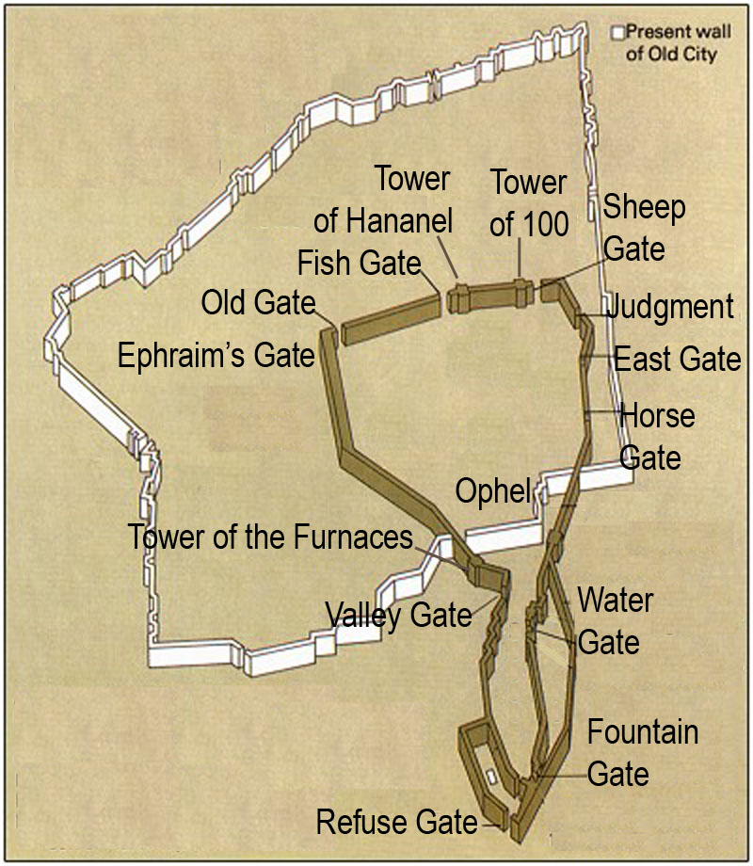But then there’s one more gate. Identified here as the Inspection Gate, we call this gate in Hebrew the Gate of Judgment.  When Jesus comes back, there will be a judgment. There’s two judgments: those for the saved and those for the unsaved. There’s two judgment seats of Christ: the “thronos” and the “bema”. The unsaved appear before the “thronos”, the Judge of the condemnation, and the saved are judged before the “bema”, to learn the magnitude of their reward.
Rebuilding the Gates Today

We live in a time in most of the western countries where the gates are devastated, and where the Lord is calling for people who will mourn over the state like Nehemiah did and begin to rebuild. There were men and there were women. People from all backgrounds, all professions, working together as families. Different groups had different jobs. Different ones had different territory. And so it’s going to be. We’re not all going to have the same ministry, we’re not all going to have the same territory, but we’re all going to have the same objective: to rebuild that which was devastated.

Nehemiah went to something that used to exist and no longer did; it was broken down. He didn’t try to rebuild the Fountain Gate first, or the Water Gate first, or the Horse Gate first. I wish we were in a good enough state we could take on Islam. We’re not. But that doesn’t mean we shouldn’t witness to Muslims. We should witness to Muslims. It doesn’t mean we shouldn’t witness to New Agers, we should. Should we pray for their salvation? Absolutely. But what it means is the church is not in the condition in this nation to throw back those powers the way the church is in the condition to throw it back in the Far East.

We have to begin rebuilding in order. Go back to the basics of the Fish Gate and the Sheep Gate. “My sheep will hear My voice”. (John 10:27) The Lamb of God that was slain for us. The Gospel is simply not emphasized or preached in so many churches any more. The hymns are about anything and everything other than the blood of the Lamb. In the Vineyard hymn book – in one Vineyard hymn book I read – they had like 80-something hymns; only 2 of them mentioned the cross or the blood.

We have to rebuild the basic gates: The Sheep Gate, the Fish Gate. “I’ll make you fishers of men”. (Matthew 4:19) OK, I thank God for the groups doing the right thing. We need places for people who are churchless because of other places’ failures. But we just can’t be clubs for Christians who’ve been abused. We just can’t be a refugee camp for people who have come out of churches because of false doctrine and because they were being financially fleeced all the time. That’s not good enough. We just can’t be a place where you want to come to because your church is ecumenical or Toronto-ized or whatever. That’s a beginning, and it’s preaching the Gospel and going fishing. These other churches are giving people hype, we’ve got to give them the truth.
Getting God’s Plan for Evangelism

One of the things we have to begin doing is to pray that we get God’s plan for evangelism. I thank God there’s tracts available, but I think that some of these meetings are going to have to begin to become evangelistic and prayer meetings praying for people to get saved. Let’s go back to the basic things: The Gospel, going fishing.

We can’t cast our nets until Jesus tells us where to do it. If we just go out with our own idea for an evangelistic program. He has to get in our boat and tell us where to cast the nets. But everybody can use a fishing rod. There’s nobody who can’t witness day-to-day and there’s nobody who can’t ask the Lord for His plan: “Jesus, please get in our boat and You show us where to cast our nets.” We’ve got to get God’s plan for evangelism. Go back to the basics: The Old Gate, the Gate of Ephraim, the Valley Gate.
Reversing the Current State

This nation would not be in the state it’s in, New Zealand would not be in the state it’s in, Australia would not be in the state it’s in, Great Britain would not be in the state it’s in, except for one reason: these nations and societies are in the state they’re in because the church is in the state it’s in. We’re supposed to be the “salt” and “light” (Matthew 5:13-16) Until we repent, there’s not going to be any repentance in society.

There’s a lot of garbage – rubbish – stuff that’s clogging up the water works. The plumbing is jammed. Nobody wants to crawl down into a pit and clean it out, but that’s what has to be done. We’ve got to realize this. There’s a lot of junk that’s in the church and in our lives that Jesus has to get rid of before the water can really flow again.

There’s no easy way out of this mess. The walls have to be rebuilt, the gates have to be repaired, there’s a lot of work to do. We’ve got to clean out all the rubbish that’s stopping up the drains and clogging up the water works; then the water can flow again. But the nobles aren’t going to support the work. It’s mainly going to be ordinary people. Always has been, always will be.

But if we follow God’s plan instead of man’s, that rubbish is going to go. And then the water will begin to flow. When the water begins to flow, it will fill the pool: A Spirit-filled church will result.

Satan doesn’t like Charismatic churches, but he’s not afraid of them. Satan doesn’t like Fundamentalist churches, but he’s not afraid of them. But when you have Spirit and truth, a church that’s based on the Word of God but also open to the fullness of the Spirit and the gifts of the Spirit, working in unison, that’s the kind of church he does not want to see. And he will do anything and everything he can to prevent a church like that from coming. He’ll get the Fundamentalists to shut off the gifts of the Spirit, to resist the Spirit, suppress the Spirit. He’ll use crazy Charismatics to discredit the gifts of the Spirit so as to give them a reason to do it. And then he’ll take the Charismatics and make them loony, and keep them away from the Bible, saying stupid things such as the case of a Pentecostal minister who said, picking up the Bible, “This book has failed us; we need more of the Spirit.” Yeah? What spirit?

Now the garbage goes, then the water flows. Then we go to war. Then we mount up for battle. Then we hitch the horses to the chariots. Then we can take on the forces of darkness.
The Signs of the Time

The East Gate – the coming of Jesus. I’ve said it a couple of times and I’ll say it one more time: If you asked me ten years ago why I thought Jesus was coming, I would have told you because of events in the Middle East, because of the reunification of Europe, the globalization of the world economy, the one-world money system and all this. I would have said that stuff. I still agree. I agree with those things more now than I did ten years ago. But it’s not the main reason I believe Jesus is coming. The main reason I believe Jesus is coming is because of the level of deception in the church.

The main leader, the evangelical archbishop of Canterbury, a Charismatic, Evangelical, born again, Bible-believing Christian stands up in Wimbley in London and tells the leaders of the evangelical churches and denominations in that country that they don’t have all the truth, that those who aren’t even born again do. They have truth, too and we need their help?

A preacher stands up in the biggest Assemblies of God church in this country and says this world is our home, I repent of ever having sworn this world is not my home any more.

Jesus is coming; the East Gate. But when He comes, there’ll be a judgment.

Those gates were devastated in the days of Nehemiah and those gates are devastated today. Nehemiah and those who joined him realized there was no easy way out of it. They realized what had to be done, they rolled up their sleeves, and they got to it, men and women alike. They all had their own jobs, their own past, their own areas of work, but they realized it had to be done. There was no easy way. It’s exactly the same today.

Those are the gates. The Baptist Union is not going to rebuild those gates; they’ve compromised with Rome. The Assemblies of God is not going to rebuild those gates. The Church of England is not going to rebuild those gates. 30 years of “Charismatic Renewal” – where’s the renewal? There is none. Those gates are not going to be rebuilt by the clergy or the leaders. The nobles will never support the work of their masters. Those gates are going to be built by the same kinds of people who have always rebuilt them: People just like you. That’s who’s going to rebuild those gates.

We have a lot of work, and the hardest job – the hardest task – is prayer.
Final Application

Share how you’re going to take this teaching further than just knowledge or understanding and apply it to your life and/or local church.
 | [PLEASE NOTE: This study is actually a direct adaptation of a sermon by Jacob Prasch of Moriel Ministries. It’s highly recommended that you obtain the original tape for the entire, unedited message. Used by permission of Moriel Ministries. Commercial use strictly prohibited.

