Amos 5 • There is No Formula
- (v.1-3) The people, living in a time of relative peace and prosperity, don’t see their need to change because they’d don’t see their self as God sees them: Already dead.
- (v.4-7) Spiritual deception is identified by an attempt to re-write both God’s Word and one’s own spiritual legacy to fit with what is now worshiped.
- (v.8-9) False worship may recognize God in some limited capacity, but not as Sovereign and Ruler over all.
- (v.10-15) God’s proof that spiritual deception has matured into false worship:
  - The visible evidence: Breaking the second tablet.
  - The invisible evidence: This proves the breaking of the first tablet.
  - God always proves there is no true love nor worship of Him by how people treat each other.
- (v.16-20) The second most visible evidence of spiritual corruption is the attempt to redefine God’s Word to fit their unbiblical behavior.
- (v.21-27) The biblical definition of “heresy” is to lay truth alongside error.
  - They continued to observe the Old Testament rituals right alongside those to other gods, believing they were still compliant with God’s Law.
  - Worship that is divided between God and false gods is, in reality, no worship at all.
  - God cannot be bound by a formula, even if you think it comes from His Word.
Application:
- How can your relationship with God be precisely measured?
In the way we treat others.
- What is a pretty good indication we’re straying from God?
Changing God’s Word and history to support something new.
- What happens to our worship of God when we embrace other things as well?
Divided worship of God is no worship of God at all.
- What happens when we attempt to use formulas to bind an outcome from God?
Nothing is assured that doesn’t begin sincerely from the heart.
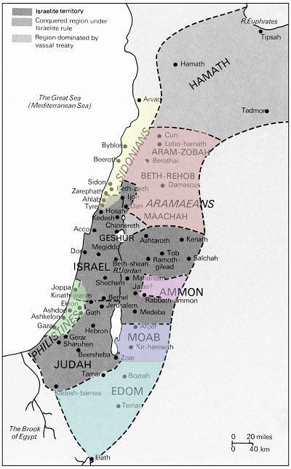
Note how that at one time, ALL of these nations were enfolded into Israel under Solomon, a picture of all nations coming to God through Israel. However, all of them subsequently rejected God and are now extinct. Some of the cities remain, but not populated by these original people groups.

