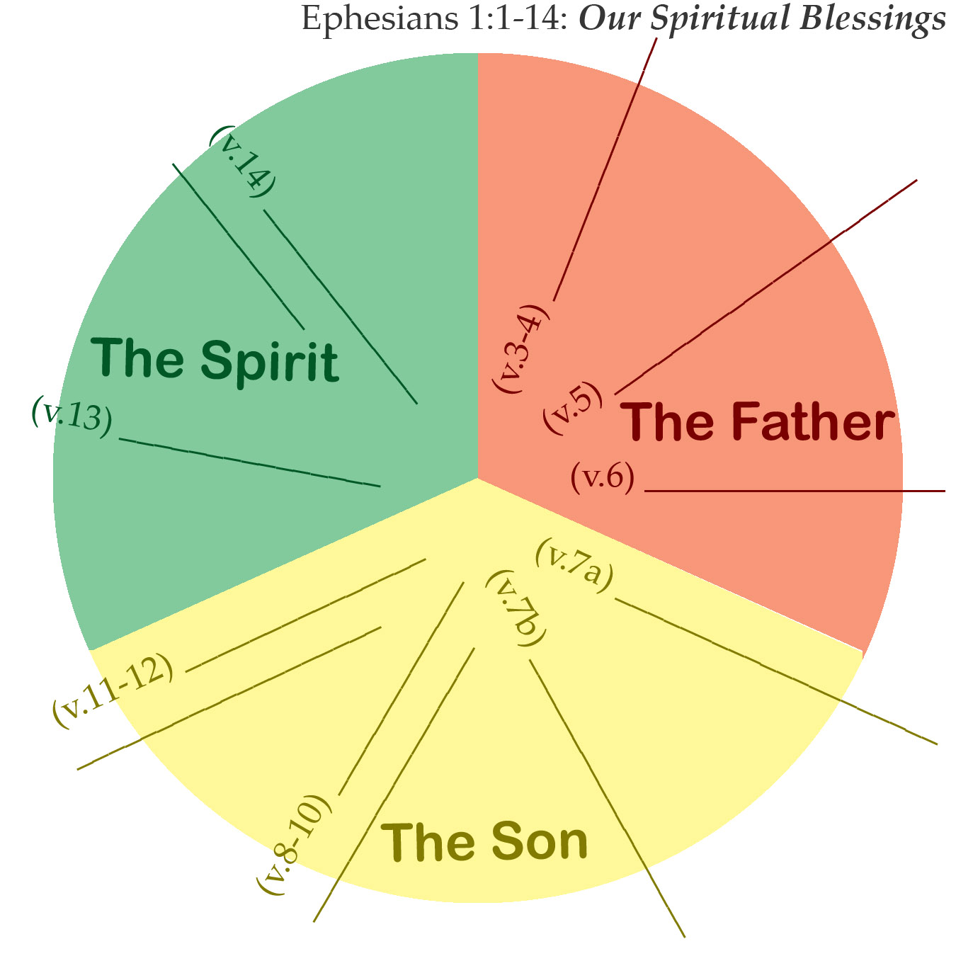

Paul’s Requests:

- (v.17) To have ___________________________.
- (v.18) To know __________________________.
- (v.18) To know __________________________.
- (v.19-23) To know _______________________.

Paul’s Requests:

- (v.17) To have ___________________________.
- (v.18) To know __________________________.
- (v.18) To know __________________________.
- (v.19-23) To know _______________________.

